
Business Question and Visualization Report

Date | 26 October 2026
Team ID
Project Name | Electric Vehicle Market Performance & Insights
Maximum Marks | 5 Marks

Visualization development transforms the supplied EV dataset into clear graphical views for exploration and decision-making. This project uses Tableau Public to compare recorded annual sales, battery technologies, driving range, battery capacity, manufacturing-country records and customer ratings.
Business Questions and Visualisation
Business questions guide the selection of measures and visual forms. The analysis uses the supplied ev_market_test.csv file in Tableau Public. Snowflake SQL is not part of this project's implementation; therefore, Tableau shelves, dimensions, measures and aggregations are provided instead of SQL code.
Business Questions and Visualisations (8 required)
- 1. Which manufacturers have the highest recorded annual sales?
  - Visualisation: Horizontal bar chart – Top 10 manufacturers; SUM(annual_sales_units), sorted descending.
  - Chart preview generated from the supplied EV dataset (not a Tableau application screenshot).
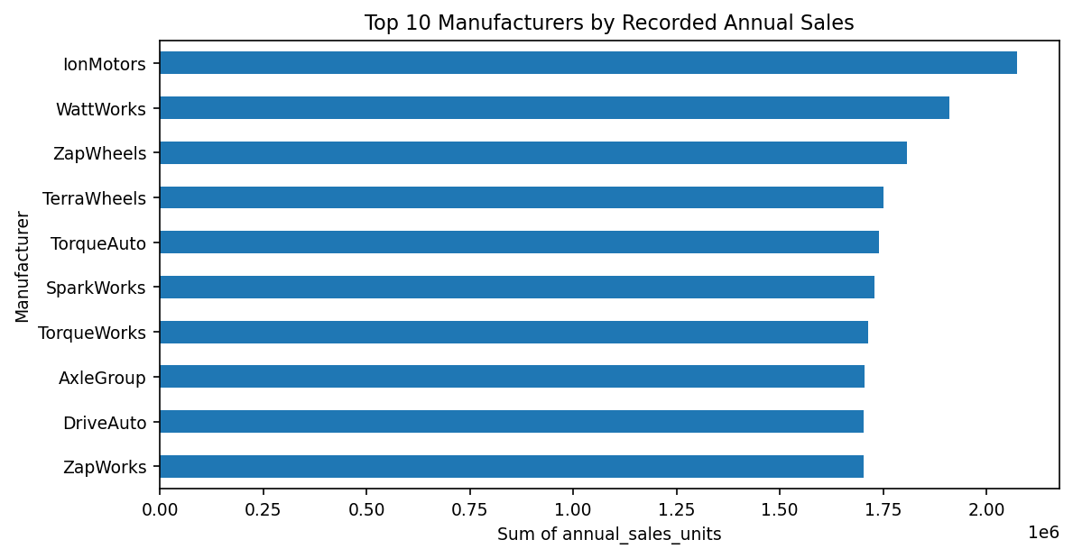
- 2. How are vehicle records distributed across battery technologies?
  - Chart preview generated from the supplied EV dataset (not a Tableau application screenshot).
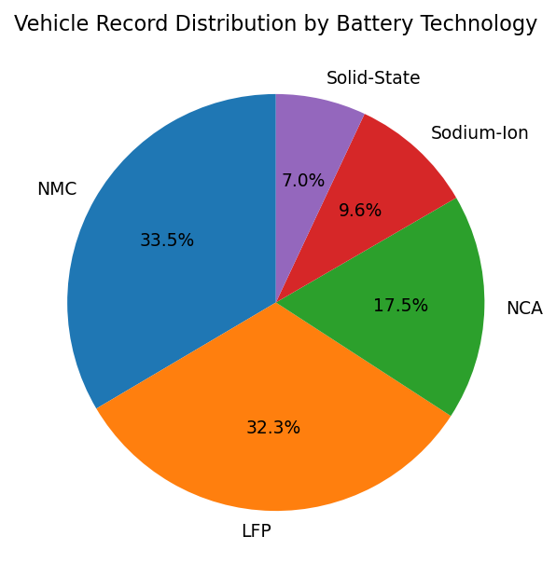
  - Tableau evidence: Use the corresponding published chart in the project dashboard/story; attach an actual screenshot if required by SkillWallet.
- Chart preview generated from the supplied EV dataset (not a Tableau application screenshot).
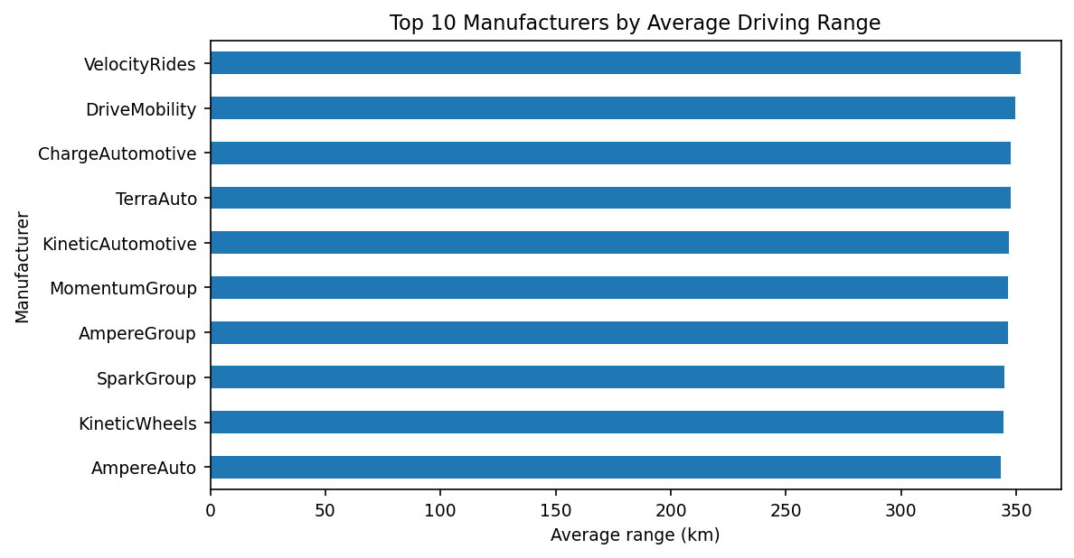
  - Visualisation: Horizontal bar chart – AVG(range_km) by manufacturer; Top 10.
  - Tableau evidence: Use the corresponding published chart in the project dashboard/story; attach an actual screenshot if required by SkillWallet. Equivalent chart evidence is available through the published Tableau Public dashboard and stories.

Note: Minimum 8 business questions and visualisations are included. Tableau is used instead of Snowflake, so SQL code is not applicable. Dataset caveats: ev_market_test.csv is a supplied test dataset; record counts are not verified real-world market share or production. Missing ratings/ranges should not be treated as zero. Actual chart screenshots are not embedded in this report. Eight dataset-derived chart previews are inserted below their respective questions. They are not captured from Tableau Public; use Tableau's own screenshots instead if the assessor specifically requires screenshots of the Tableau interface.

4. What relationship is visible between battery capacity and driving range?
Visualisation: Scatter plot – battery_capacity_kwh against range_km; colour by battery_type. Association does not prove causation.
Chart preview generated from the supplied EV dataset (not a Tableau application screenshot).
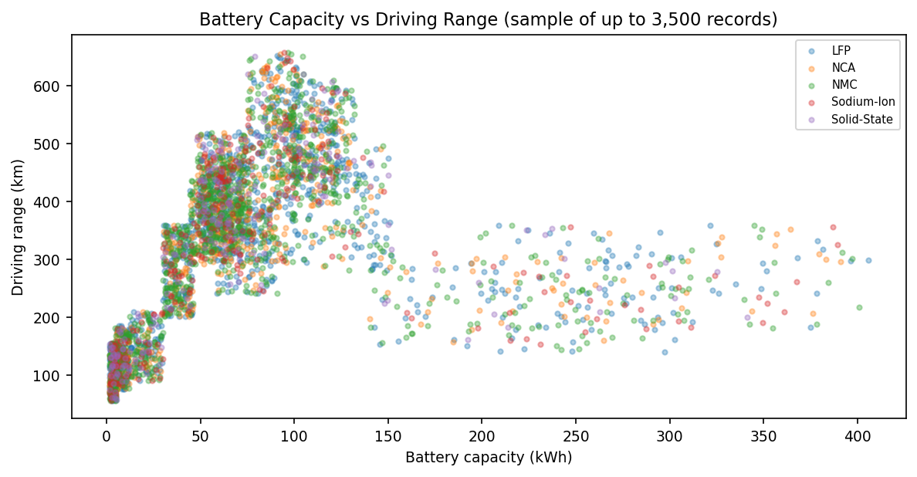
5. Which manufacturing countries have the most vehicle records?
Visualisation: Bar chart or map – COUNTD(vehicle_id) by manufacturing_country. Counts are records, not factory output.
Chart preview generated from the supplied EV dataset (not a Tableau application screenshot).
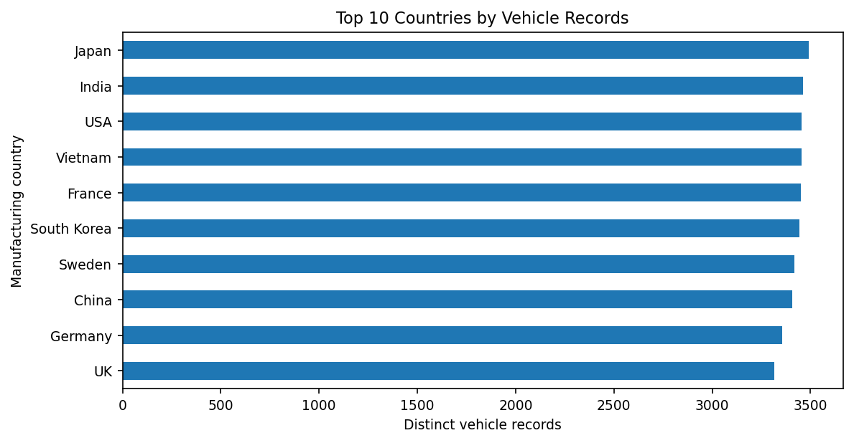
6. Which manufacturers have the highest average customer ratings?
Visualisation: Horizontal bar chart – AVG(customer_rating) by manufacturer; use available non-null ratings.
Chart preview generated from the supplied EV dataset (not a Tableau application screenshot).
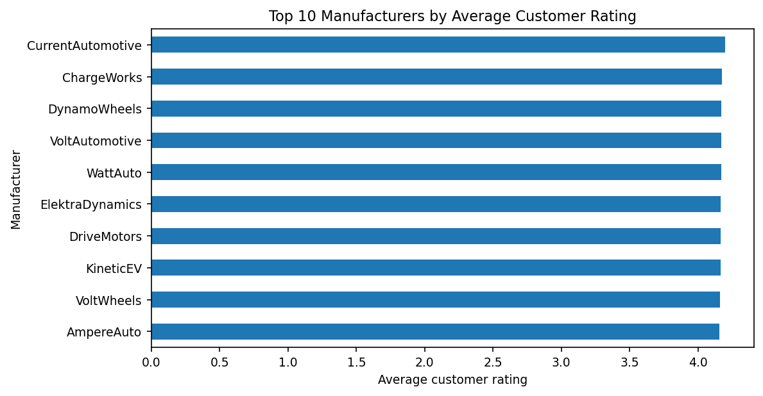
7. How does average battery capacity vary by battery technology?
Visualisation: Bar chart – AVG(battery_capacity_kwh) by battery_type.
Chart preview generated from the supplied EV dataset (not a Tableau application screenshot).
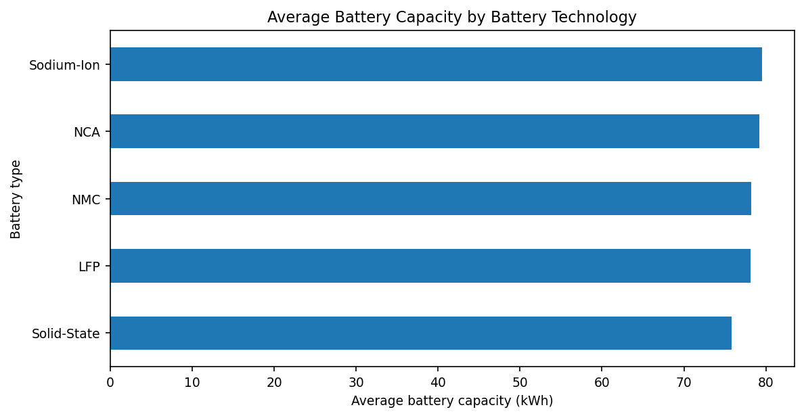
8. How do recorded annual sales vary by model year?
Visualisation: Line chart – SUM(annual_sales_units) by model_year. This is grouped by model year, not transaction year.
Chart preview generated from the supplied EV dataset (not a Tableau application screenshot).
